**Professional Programming Practice – Assignment 4**

**HOANG, Van Cuong**

**11613599**

**BUG 7– Player cannot change his name and balance**

**Description:** The player’s is hardcoded Fred with balance of 100, but what if someone else who’s different name wants to play the game with a different amount of balance?

1. **Replication**

At the Main class the player instance is initialise with name is Fred and balance is 100:

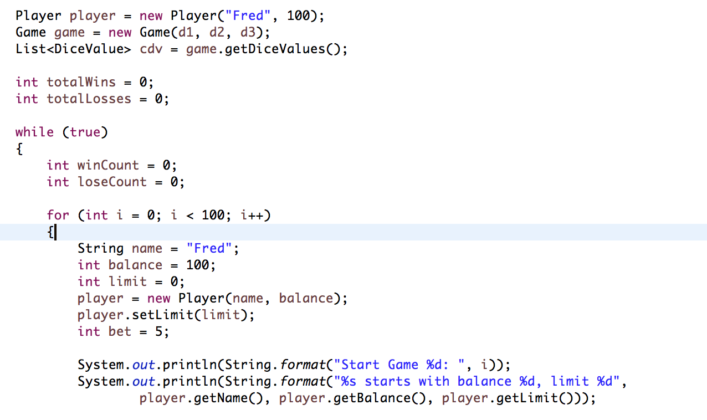

The name and balance is hard coded.

**2. Simplification & Tracing**

Before hard coding the variables, the game should offer a choice for player to enter his name and his available balance:

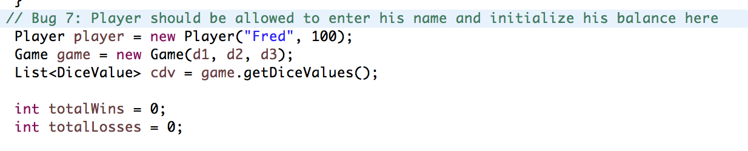

**4. Resolution**

Code is added to ask for player’s name and his balance. Exceptions are checked and default balance can be used when an exception caught:

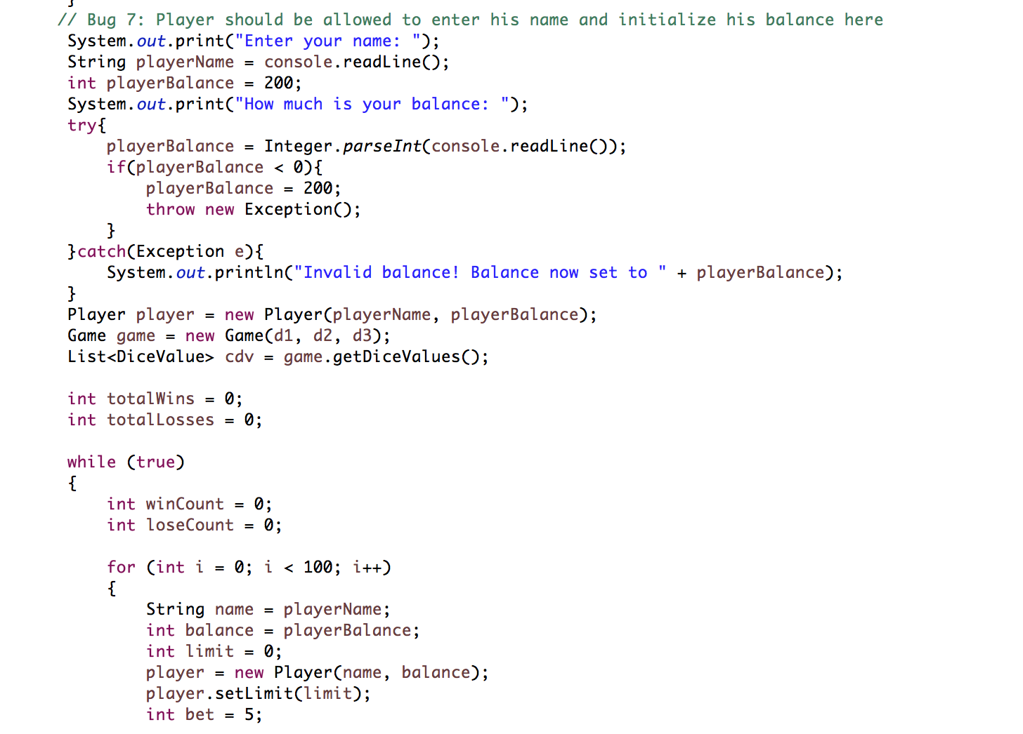

Now if John plays the game:

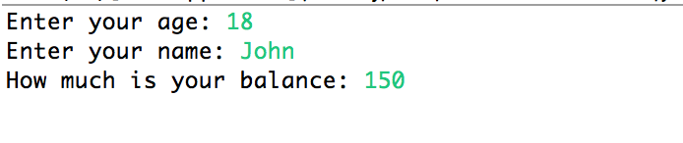

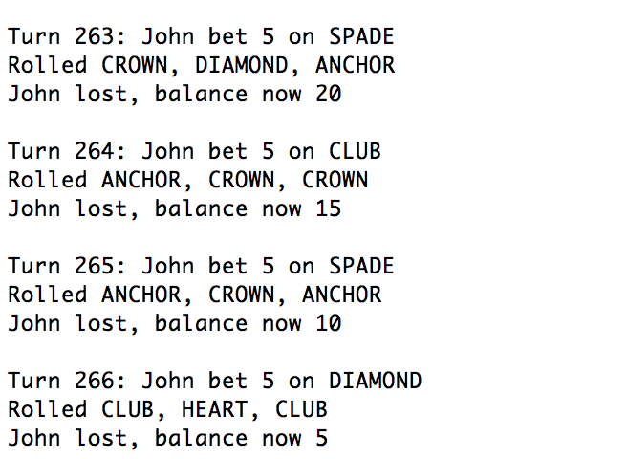

He also starts with his entered balance (150):

